1 run...

training 1 epoch...

33.212798833847046 seconds used......

1 training finished! average train loss: 0.9352000445229202

evaluating...

Confusion matrix, without normalization

[[ 0 0 124]

[ 0 2 162]

[ 0 0 865]]

Normalized confusion matrix

[[0. 0. 1. ]

[0. 0.01219512 0.98780488]

[0. 0. 1. ]]

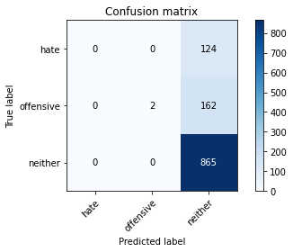

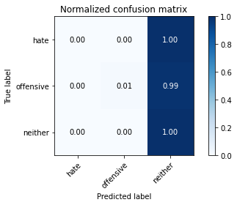

/opt/conda/lib/python3.7/site-packages/sklearn/metrics/_classification.py:1245: UndefinedMetricWarning: Precision and F-score are ill-defined and being set to 0.0 in labels with no predicted samples. Use `zero_division` parameter to control this behavior.

_warn_prf(average, modifier, msg_start, len(result))

/opt/conda/lib/python3.7/site-packages/sklearn/metrics/_classification.py:1245: UndefinedMetricWarning: Precision and F-score are ill-defined and being set to 0.0 in labels with no predicted samples. Use `zero_division` parameter to control this behavior.

_warn_prf(average, modifier, msg_start, len(result))

/opt/conda/lib/python3.7/site-packages/sklearn/metrics/_classification.py:1245: UndefinedMetricWarning: Precision and F-score are ill-defined and being set to 0.0 in labels with no predicted samples. Use `zero_division` parameter to control this behavior.

_warn_prf(average, modifier, msg_start, len(result))

precision recall f1-score support

hate 0.00 0.00 0.00 124

offensive 1.00 0.01 0.02 164

neither 0.75 1.00 0.86 865

accuracy 0.75 1153

macro avg 0.58 0.34 0.29 1153

weighted avg 0.71 0.75 0.65 1153

average eval_loss: 0.7653756018342643, accuracy: 0.7519514310494363

training 2 epoch...

33.21273612976074 seconds used......

2 training finished! average train loss: 0.8793412680918853

evaluating...

Confusion matrix, without normalization

[[ 0 8 116]

[ 0 22 142]

[ 0 25 840]]

Normalized confusion matrix

[[0. 0.06451613 0.93548387]

[0. 0.13414634 0.86585366]

[0. 0.02890173 0.97109827]]

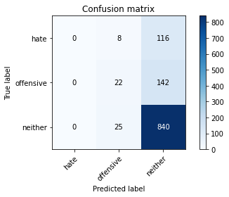

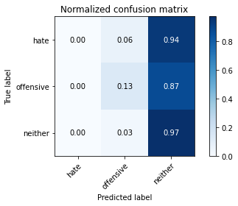

/opt/conda/lib/python3.7/site-packages/sklearn/metrics/_classification.py:1245: UndefinedMetricWarning: Precision and F-score are ill-defined and being set to 0.0 in labels with no predicted samples. Use `zero_division` parameter to control this behavior.

_warn_prf(average, modifier, msg_start, len(result))

/opt/conda/lib/python3.7/site-packages/sklearn/metrics/_classification.py:1245: UndefinedMetricWarning: Precision and F-score are ill-defined and being set to 0.0 in labels with no predicted samples. Use `zero_division` parameter to control this behavior.

_warn_prf(average, modifier, msg_start, len(result))

/opt/conda/lib/python3.7/site-packages/sklearn/metrics/_classification.py:1245: UndefinedMetricWarning: Precision and F-score are ill-defined and being set to 0.0 in labels with no predicted samples. Use `zero_division` parameter to control this behavior.

_warn_prf(average, modifier, msg_start, len(result))

precision recall f1-score support

hate 0.00 0.00 0.00 124

offensive 0.40 0.13 0.20 164

neither 0.77 0.97 0.86 865

accuracy 0.75 1153

macro avg 0.39 0.37 0.35 1153

weighted avg 0.63 0.75 0.67 1153

average eval_loss: 0.7722760366982427, accuracy: 0.7476149176062445

training 3 epoch...

33.24089503288269 seconds used......

3 training finished! average train loss: 0.8019486370753917

evaluating...

Confusion matrix, without normalization

[[ 0 21 103]

[ 0 41 123]

[ 0 70 795]]

Normalized confusion matrix

[[0. 0.16935484 0.83064516]

[0. 0.25 0.75 ]

[0. 0.08092486 0.91907514]]

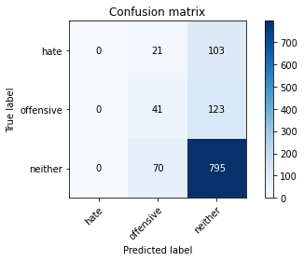

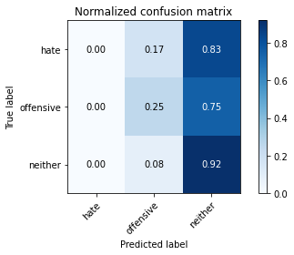

/opt/conda/lib/python3.7/site-packages/sklearn/metrics/_classification.py:1245: UndefinedMetricWarning: Precision and F-score are ill-defined and being set to 0.0 in labels with no predicted samples. Use `zero_division` parameter to control this behavior.

_warn_prf(average, modifier, msg_start, len(result))

/opt/conda/lib/python3.7/site-packages/sklearn/metrics/_classification.py:1245: UndefinedMetricWarning: Precision and F-score are ill-defined and being set to 0.0 in labels with no predicted samples. Use `zero_division` parameter to control this behavior.

_warn_prf(average, modifier, msg_start, len(result))

/opt/conda/lib/python3.7/site-packages/sklearn/metrics/_classification.py:1245: UndefinedMetricWarning: Precision and F-score are ill-defined and being set to 0.0 in labels with no predicted samples. Use `zero_division` parameter to control this behavior.

_warn_prf(average, modifier, msg_start, len(result))

precision recall f1-score support

hate 0.00 0.00 0.00 124

offensive 0.31 0.25 0.28 164

neither 0.78 0.92 0.84 865

accuracy 0.73 1153

macro avg 0.36 0.39 0.37 1153

weighted avg 0.63 0.73 0.67 1153

average eval_loss: 0.7386012180098172, accuracy: 0.7250650477016479

training 4 epoch...

33.12966251373291 seconds used......

4 training finished! average train loss: 0.6751285208573521

evaluating...

Confusion matrix, without normalization

[[ 19 15 90]

[ 12 29 123]

[ 66 35 764]]

Normalized confusion matrix

[[0.15322581 0.12096774 0.72580645]

[0.07317073 0.17682927 0.75 ]

[0.07630058 0.04046243 0.88323699]]

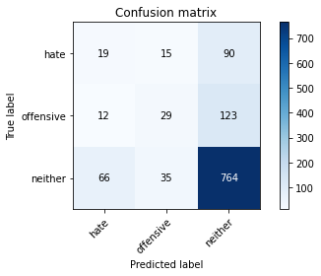

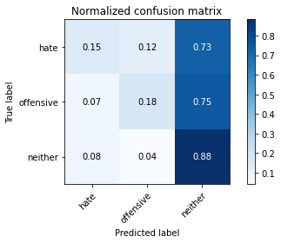

precision recall f1-score support

hate 0.20 0.15 0.17 124

offensive 0.37 0.18 0.24 164

neither 0.78 0.88 0.83 865

accuracy 0.70 1153

macro avg 0.45 0.40 0.41 1153

weighted avg 0.66 0.70 0.67 1153

average eval_loss: 0.8001248425450819, accuracy: 0.7042497831743278

training 5 epoch...

33.26817536354065 seconds used......

5 training finished! average train loss: 0.5306129365549153

evaluating...

Confusion matrix, without normalization

[[ 15 25 84]

[ 15 47 102]

[ 77 78 710]]

Normalized confusion matrix

[[0.12096774 0.2016129 0.67741935]

[0.09146341 0.28658537 0.62195122]

[0.08901734 0.09017341 0.82080925]]

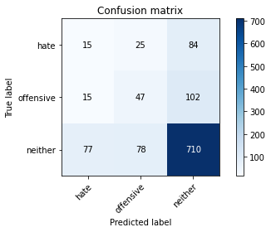

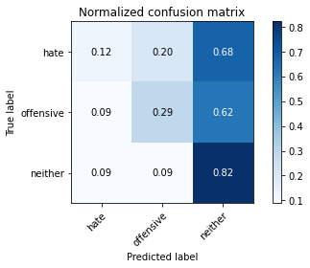

precision recall f1-score support

hate 0.14 0.12 0.13 124

offensive 0.31 0.29 0.30 164

neither 0.79 0.82 0.81 865

accuracy 0.67 1153

macro avg 0.42 0.41 0.41 1153

weighted avg 0.65 0.67 0.66 1153

average eval_loss: 0.8869960719141466, accuracy: 0.6695576756287944

training 6 epoch...

33.16836500167847 seconds used......

6 training finished! average train loss: 0.37693889489963195

evaluating...

Confusion matrix, without normalization

[[ 35 29 60]

[ 27 69 68]

[195 106 564]]

Normalized confusion matrix

[[0.28225806 0.23387097 0.48387097]

[0.16463415 0.42073171 0.41463415]

[0.22543353 0.12254335 0.65202312]]

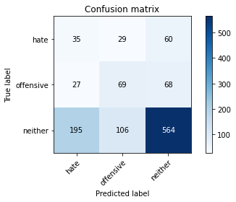

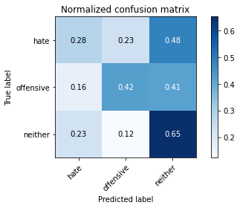

precision recall f1-score support

hate 0.14 0.28 0.18 124

offensive 0.34 0.42 0.37 164

neither 0.82 0.65 0.72 865

accuracy 0.58 1153

macro avg 0.43 0.45 0.43 1153

weighted avg 0.67 0.58 0.62 1153

average eval_loss: 1.0372323100936824, accuracy: 0.5793581960104076

training 7 epoch...

33.204591035842896 seconds used......

7 training finished! average train loss: 0.2660521205908813

evaluating...

Confusion matrix, without normalization

[[ 42 24 58]

[ 34 56 74]

[214 100 551]]

Normalized confusion matrix

[[0.33870968 0.19354839 0.46774194]

[0.20731707 0.34146341 0.45121951]

[0.24739884 0.11560694 0.63699422]]

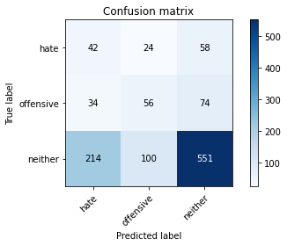

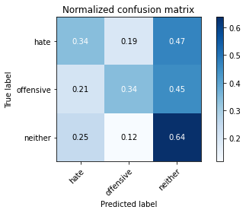

precision recall f1-score support

hate 0.14 0.34 0.20 124

offensive 0.31 0.34 0.33 164

neither 0.81 0.64 0.71 865

accuracy 0.56 1153

macro avg 0.42 0.44 0.41 1153

weighted avg 0.67 0.56 0.60 1153

average eval_loss: 1.3473963860807747, accuracy: 0.5628794449262793

training 8 epoch...

33.17683148384094 seconds used......

8 training finished! average train loss: 0.18400137984025397

evaluating...

Confusion matrix, without normalization

[[ 39 21 64]

[ 29 67 68]

[152 109 604]]

Normalized confusion matrix

[[0.31451613 0.16935484 0.51612903]

[0.17682927 0.40853659 0.41463415]

[0.17572254 0.12601156 0.6982659 ]]

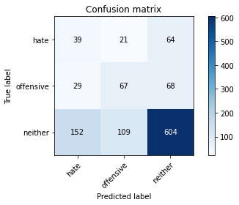

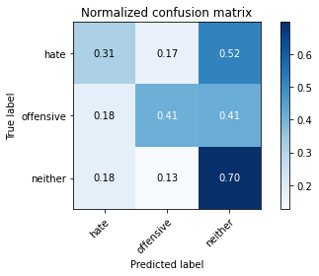

precision recall f1-score support

hate 0.18 0.31 0.23 124

offensive 0.34 0.41 0.37 164

neither 0.82 0.70 0.75 865

accuracy 0.62 1153

macro avg 0.45 0.47 0.45 1153

weighted avg 0.68 0.62 0.64 1153

average eval_loss: 1.5642796425983823, accuracy: 0.6157849089332177

training 9 epoch...

33.074952840805054 seconds used......

9 training finished! average train loss: 0.11069168136916012

evaluating...

Confusion matrix, without normalization

[[ 38 25 61]

[ 32 68 64]

[188 127 550]]

Normalized confusion matrix

[[0.30645161 0.2016129 0.49193548]

[0.19512195 0.41463415 0.3902439 ]

[0.21734104 0.14682081 0.63583815]]

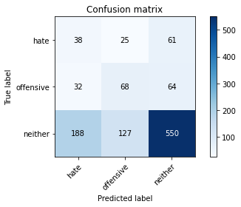

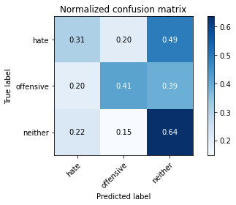

precision recall f1-score support

hate 0.15 0.31 0.20 124

offensive 0.31 0.41 0.35 164

neither 0.81 0.64 0.71 865

accuracy 0.57 1153

macro avg 0.42 0.45 0.42 1153

weighted avg 0.67 0.57 0.61 1153

average eval_loss: 1.6790416723695294, accuracy: 0.5689505637467476

training 10 epoch...

33.230547189712524 seconds used......

10 training finished! average train loss: 0.07532755629820653

evaluating...

Confusion matrix, without normalization

[[ 49 15 60]

[ 44 51 69]

[205 91 569]]

Normalized confusion matrix

[[0.39516129 0.12096774 0.48387097]

[0.26829268 0.31097561 0.42073171]

[0.23699422 0.10520231 0.65780347]]

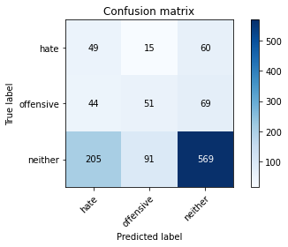

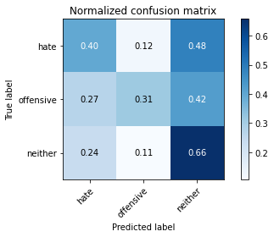

precision recall f1-score support

hate 0.16 0.40 0.23 124

offensive 0.32 0.31 0.32 164

neither 0.82 0.66 0.73 865

accuracy 0.58 1153

macro avg 0.43 0.45 0.43 1153

weighted avg 0.68 0.58 0.62 1153

average eval_loss: 1.8847338331156764, accuracy: 0.5802254986990459

training 11 epoch...

33.18694448471069 seconds used......

11 training finished! average train loss: 0.04626256161140526

evaluating...

Confusion matrix, without normalization

[[ 59 13 52]

[ 61 48 55]

[277 74 514]]

Normalized confusion matrix

[[0.47580645 0.10483871 0.41935484]

[0.37195122 0.29268293 0.33536585]

[0.32023121 0.08554913 0.59421965]]

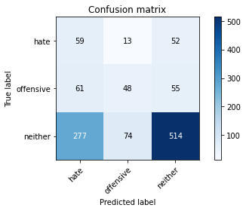

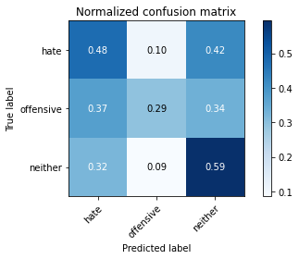

precision recall f1-score support

hate 0.15 0.48 0.23 124

offensive 0.36 0.29 0.32 164

neither 0.83 0.59 0.69 865

accuracy 0.54 1153

macro avg 0.44 0.45 0.41 1153

weighted avg 0.69 0.54 0.59 1153

average eval_loss: 2.2844834759317596, accuracy: 0.5385949696444059

training 12 epoch...

33.0005578994751 seconds used......

12 training finished! average train loss: 0.030001451642373292

evaluating...

Confusion matrix, without normalization

[[ 41 21 62]

[ 45 51 68]

[200 97 568]]

Normalized confusion matrix

[[0.33064516 0.16935484 0.5 ]

[0.27439024 0.31097561 0.41463415]

[0.23121387 0.11213873 0.6566474 ]]

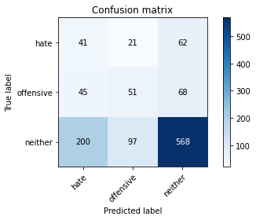

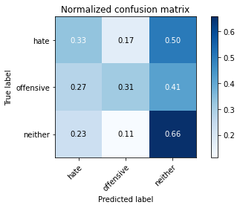

precision recall f1-score support

hate 0.14 0.33 0.20 124

offensive 0.30 0.31 0.31 164

neither 0.81 0.66 0.73 865

accuracy 0.57 1153

macro avg 0.42 0.43 0.41 1153

weighted avg 0.67 0.57 0.61 1153

average eval_loss: 2.4440252040994577, accuracy: 0.572419774501301

training 13 epoch...

33.154361963272095 seconds used......

13 training finished! average train loss: 0.03226768407106889

evaluating...

Confusion matrix, without normalization

[[ 41 29 54]

[ 36 76 52]

[206 146 513]]

Normalized confusion matrix

[[0.33064516 0.23387097 0.43548387]

[0.2195122 0.46341463 0.31707317]

[0.23815029 0.16878613 0.59306358]]

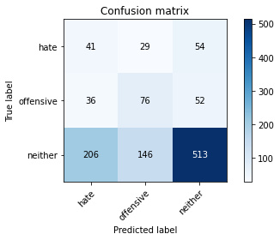

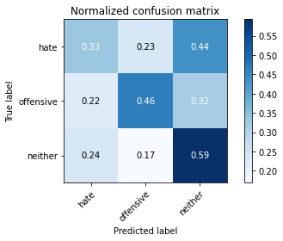

precision recall f1-score support

hate 0.14 0.33 0.20 124

offensive 0.30 0.46 0.37 164

neither 0.83 0.59 0.69 865

accuracy 0.55 1153

macro avg 0.43 0.46 0.42 1153

weighted avg 0.68 0.55 0.59 1153

average eval_loss: 2.479565842398282, accuracy: 0.546400693842151

training 14 epoch...

33.28065800666809 seconds used......

14 training finished! average train loss: 0.05357177615020291

evaluating...

Confusion matrix, without normalization

[[ 47 13 64]

[ 42 52 70]

[201 84 580]]

Normalized confusion matrix

[[0.37903226 0.10483871 0.51612903]

[0.25609756 0.31707317 0.42682927]

[0.23236994 0.09710983 0.67052023]]

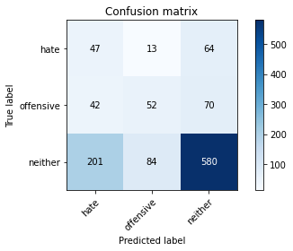

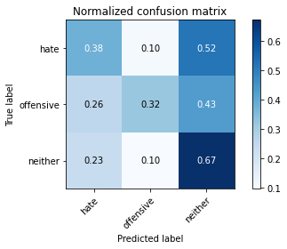

precision recall f1-score support

hate 0.16 0.38 0.23 124

offensive 0.35 0.32 0.33 164

neither 0.81 0.67 0.73 865

accuracy 0.59 1153

macro avg 0.44 0.46 0.43 1153

weighted avg 0.68 0.59 0.62 1153

average eval_loss: 1.8152580168740502, accuracy: 0.5888985255854293

training 15 epoch...

33.421536684036255 seconds used......

15 training finished! average train loss: 0.02951070076071597

evaluating...

Confusion matrix, without normalization

[[ 66 14 44]

[ 55 56 53]

[301 101 463]]

Normalized confusion matrix

[[0.53225806 0.11290323 0.35483871]

[0.33536585 0.34146341 0.32317073]

[0.34797688 0.11676301 0.53526012]]

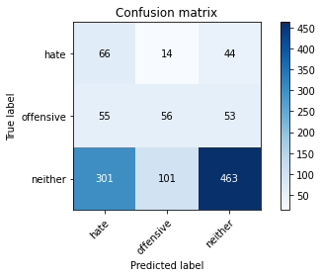

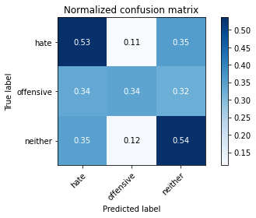

precision recall f1-score support

hate 0.16 0.53 0.24 124

offensive 0.33 0.34 0.33 164

neither 0.83 0.54 0.65 865

accuracy 0.51 1153

macro avg 0.44 0.47 0.41 1153

weighted avg 0.68 0.51 0.56 1153

average eval_loss: 2.9236312631903023, accuracy: 0.5073720728534259

training 16 epoch...

33.34961462020874 seconds used......

16 training finished! average train loss: 0.039218173808904536

evaluating...

Confusion matrix, without normalization

[[ 34 16 74]

[ 20 49 95]

[140 92 633]]

Normalized confusion matrix

[[0.27419355 0.12903226 0.59677419]

[0.12195122 0.29878049 0.57926829]

[0.16184971 0.10635838 0.73179191]]

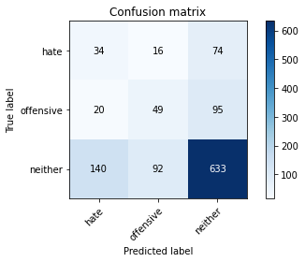

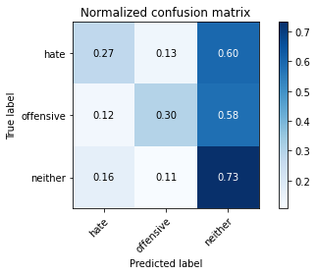

precision recall f1-score support

hate 0.18 0.27 0.21 124

offensive 0.31 0.30 0.31 164

neither 0.79 0.73 0.76 865

accuracy 0.62 1153

macro avg 0.43 0.43 0.43 1153

weighted avg 0.66 0.62 0.64 1153

average eval_loss: 1.9940354114976422, accuracy: 0.6209887250650477

training 17 epoch...

33.34158658981323 seconds used......

17 training finished! average train loss: 0.032933063627699065

evaluating...

Confusion matrix, without normalization

[[ 40 24 60]

[ 33 69 62]

[183 151 531]]

Normalized confusion matrix

[[0.32258065 0.19354839 0.48387097]

[0.20121951 0.42073171 0.37804878]

[0.21156069 0.17456647 0.61387283]]

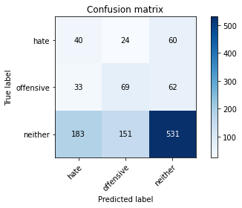

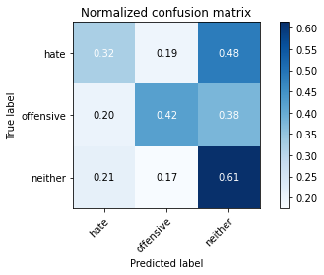

precision recall f1-score support

hate 0.16 0.32 0.21 124

offensive 0.28 0.42 0.34 164

neither 0.81 0.61 0.70 865

accuracy 0.56 1153

macro avg 0.42 0.45 0.42 1153

weighted avg 0.67 0.56 0.60 1153

average eval_loss: 2.5619924232877533, accuracy: 0.5550737207285342

training 18 epoch...

33.358237743377686 seconds used......

18 training finished! average train loss: 0.0423964130774231

evaluating...

Confusion matrix, without normalization

[[ 44 30 50]

[ 41 67 56]

[230 140 495]]

Normalized confusion matrix

[[0.35483871 0.24193548 0.40322581]

[0.25 0.40853659 0.34146341]

[0.26589595 0.16184971 0.57225434]]

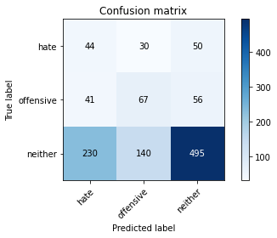

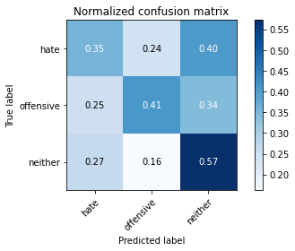

precision recall f1-score support

hate 0.14 0.35 0.20 124

offensive 0.28 0.41 0.33 164

neither 0.82 0.57 0.68 865

accuracy 0.53 1153

macro avg 0.42 0.45 0.40 1153

weighted avg 0.67 0.53 0.58 1153

average eval_loss: 2.8417271334549477, accuracy: 0.5255854293148309

training 19 epoch...

33.22268462181091 seconds used......

19 training finished! average train loss: 0.01803081230597758

evaluating...

Confusion matrix, without normalization

[[ 56 20 48]

[ 44 61 59]

[249 117 499]]

Normalized confusion matrix

[[0.4516129 0.16129032 0.38709677]

[0.26829268 0.37195122 0.3597561 ]

[0.28786127 0.13526012 0.57687861]]

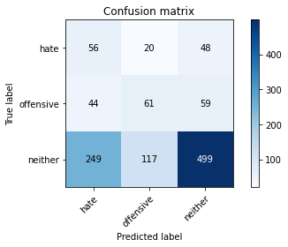

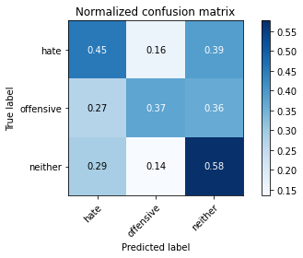

precision recall f1-score support

hate 0.16 0.45 0.24 124

offensive 0.31 0.37 0.34 164

neither 0.82 0.58 0.68 865

accuracy 0.53 1153

macro avg 0.43 0.47 0.42 1153

weighted avg 0.68 0.53 0.58 1153

average eval_loss: 2.7397109660609016, accuracy: 0.5342584562012143

training 20 epoch...

33.36018419265747 seconds used......

20 training finished! average train loss: 0.027236067261046226

evaluating...

Confusion matrix, without normalization

[[ 42 21 61]

[ 33 58 73]

[173 107 585]]

Normalized confusion matrix

[[0.33870968 0.16935484 0.49193548]

[0.20121951 0.35365854 0.44512195]

[0.2 0.12369942 0.67630058]]

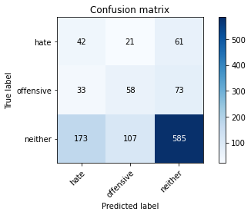

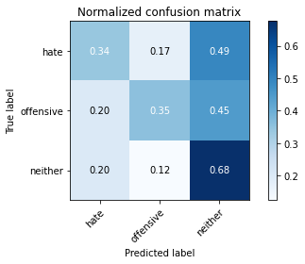

precision recall f1-score support

hate 0.17 0.34 0.23 124

offensive 0.31 0.35 0.33 164

neither 0.81 0.68 0.74 865

accuracy 0.59 1153

macro avg 0.43 0.46 0.43 1153

weighted avg 0.67 0.59 0.63 1153

average eval_loss: 2.2143813484701615, accuracy: 0.5941023417172593